Assignment no .12
Hashing

Course Name : Data Structures-I
Course Code : CS2301
Div : SEDA-B
Student Name : Yashraj Dinesh Hande
Roll Number : 18
Date of Submission : 28/11/2025

Problem 1: WAP to simulate a faculty database as a hash table. Search a particular faculty by using 'divide' as a hash function for linear probing with chaining without replacement method of collision handling technique. Assume suitable data for faculty record.

CODE:
#include <iostream>
#include <list> // For linked list
using namespace std;

class HashTable {
private:
int size; // number of buckets
list<int> *table; // array of linked lists

public:
// Constructor
HashTable(int s) {
size = s;
table = new list<int>[size];
}

// Hash function
int hashFunction(int key) {
return key % size;
}

// Insert key
void insert(int key) {
int index = hashFunction(key);
table[index].push_back(key);
cout << "Inserted key " << key << " at index " << index << endl;
}

// Search key
void search(int key) {
int index = hashFunction(key);
for (auto it = table[index].begin(); it != table[index].end(); ++it) {
if (*it == key) {
cout << "Key " << key << " found at index " << index << endl;
return;
}
}
cout << "Key " << key << " not found!" << endl;
}

// Delete key
void remove(int key) {
int index = hashFunction(key);
auto it = table[index].begin();
while (it != table[index].end()) {
if (*it == key) {
it = table[index].erase(it);
cout << "Key " << key << " deleted from index " << index << endl;
return;
} else {
++it;
}
}
cout << "Key " << key << " not found for deletion!" << endl;
}

// Display table
void display() {
cout << "\nHash Table (Separate Chaining):\n";
for (int i = 0; i < size; i++) {
cout << "Index " << i << ": ";
if (table[i].empty()) {
cout << "EMPTY";
} else {
for (auto x : table[i]) {
cout << x << " -> ";
}
cout << "NULL";
}
cout << endl;
}
}
};

int main() {
int size;
cout << "Enter hash table size: ";
cin >> size;
HashTable ht(size);
int choice, key;
do {
cout << "\n--- Hash Table (Separate Chaining) ---";
cout << "\n1. Insert Key";
cout << "\n2. Search Key";
cout << "\n3. Delete Key";
cout << "\n4. Display Table";
cout << "\n5. Exit";
cout << "\nEnter your choice: ";
cin >> choice;

switch (choice) {
case 1:
cout << "Enter key to insert: ";
cin >> key;
ht.insert(key);
break;
case 2:
cout << "Enter key to search: ";
cin >> key;
ht.search(key);
break;
case 3:
cout << "Enter key to delete: ";
cin >> key;
ht.remove(key);
break;
case 4:
ht.display();
break;
case 5:
cout << "Exiting...\n";
break;
default:
cout << "Invalid choice!\n";
}
} while (choice != 5);

return 0;
}

OUTPUT:
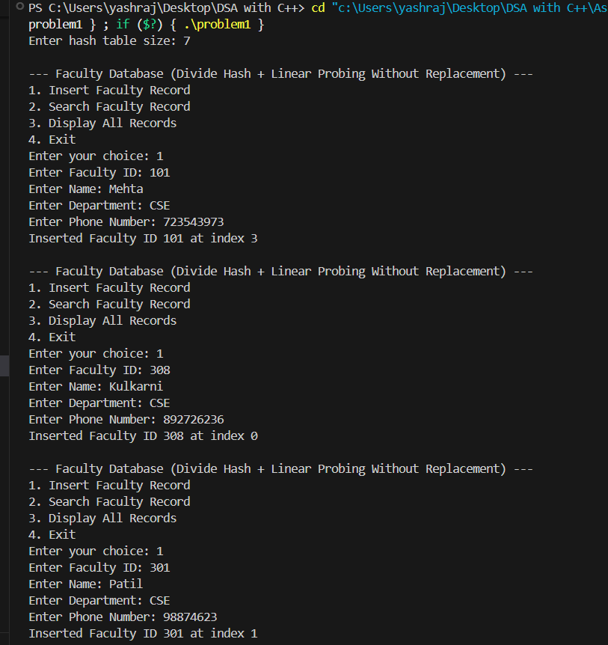
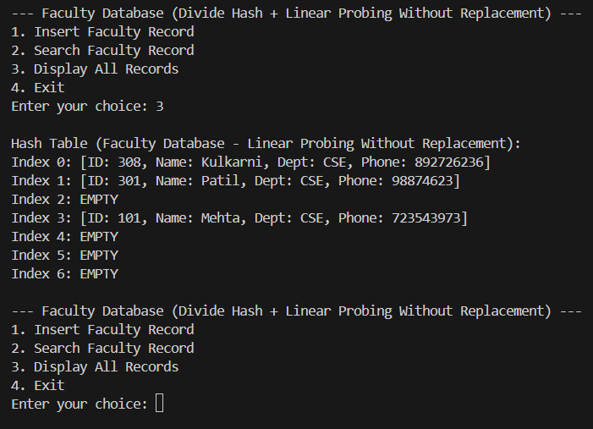
Problem 2: WAP to simulate a faculty database as a hash table. Search a particular faculty by using MOD as a hash function for linear probing with chaining with replacement method of collision handling technique. Assume suitable data for faculty record.

CODE:
#include <iostream>
#include <string>
using namespace std;

// Faculty record structure
struct Faculty {
int id;
string name;
string dept;
string phone;
int chain; // To create logical chain link (index of next record)
};

// Hash table class implementing MOD hash + Linear Probing with Replacement
class HashTable {
private:
Faculty* table;
bool* occupied;
int size;

// Hash function using MOD method
int hashFunction(int key) {
return key % size;
}

public:
// Constructor
HashTable(int s) {
size = s;
table = new Faculty[size];
occupied = new bool[size];
for (int i = 0; i < size; i++) {
occupied[i] = false;
table[i].chain = -1; // -1 = no next link
}
}

// Insert record with replacement
void insertFaculty(int id, string name, string dept, string phone) {
int index = hashFunction(id);

// If slot empty -> place directly
if (!occupied[index]) {
table[index].id = id;
table[index].name = name;
table[index].dept = dept;
table[index].phone = phone;
occupied[index] = true;
table[index].chain = -1;
cout << "Inserted Faculty ID " << id << " at index " << index << endl;
return;
}

// Collision occurs
int existingHash = hashFunction(table[index].id);
if (existingHash != index) {
// Existing record doesn't belong here → Replace it
cout << "Collision: Replacing record ID " << table[index].id
<< " with new record ID " << id << " (With Replacement)\n";

// Save old record
Faculty temp = table[index];

// Insert new record in its rightful place
table[index].id = id;
table[index].name = name;
table[index].dept = dept;
table[index].phone = phone;
table[index].chain = -1;
occupied[index] = true;

// Reinsert displaced record
insertWithoutReplacement(temp.id, temp.name, temp.dept, temp.phone);
} else {
// Same hash area → place new record in next free slot (chain link)
int next = (index + 1) % size;
while (occupied[next]) {
next = (next + 1) % size;
if (next == index) {
cout << "Hash Table Full! Cannot insert record for ID " << id << endl;
return;
}
}
table[next].id = id;
table[next].name = name;
table[next].dept = dept;
table[next].phone = phone;
table[next].chain = -1;
occupied[next] = true;

// Update chain link
int temp = index;
while (table[temp].chain != -1)
temp = table[temp].chain;
table[temp].chain = next;

cout << "Inserted Faculty ID " << id << " at index " << next << " (Chained)\n";
}
}

// Helper: insert without replacement (for displaced record)
void insertWithoutReplacement(int id, string name, string dept, string phone) {
int index = hashFunction(id);
int next = index;

while (occupied[next]) {
next = (next + 1) % size;
if (next == index) {
cout << "Hash Table Full! Cannot insert record for displaced ID " << id << endl;
return;
}
}

table[next].id = id;
table[next].name = name;
table[next].dept = dept;
table[next].phone = phone;
table[next].chain = -1;
occupied[next] = true;

// Update chain link from original hash index
int temp = index;
while (table[temp].chain != -1)
temp = table[temp].chain;
table[temp].chain = next;

cout << "Reinserted displaced record ID " << id << " at index " << next << endl;
}

// Search record
void searchFaculty(int id) {
int index = hashFunction(id);
int temp = index;

while (temp != -1) {
if (occupied[temp] && table[temp].id == id) {
cout << "\nFaculty Found at index " << temp << ":\n";
cout << "Faculty ID : " << table[temp].id << endl;
cout << "Name : " << table[temp].name << endl;
cout << "Department : " << table[temp].dept << endl;
cout << "Phone No. : " << table[temp].phone << endl;
return;
}
temp = table[temp].chain;
}
cout << "\nFaculty with ID " << id << " not found!\n";
}

// Display entire table
void displayTable() {
cout << "\nHash Table (Linear Probing with Chaining + Replacement):\n";
cout << "Index\tID\tName\tDept\tPhone\tChain\n";
cout << "-------------------------------------------------------\n";
for (int i = 0; i < size; i++) {
if (occupied[i])
cout << i << "\t" << table[i].id << "\t" << table[i].name
<< "\t" << table[i].dept << "\t" << table[i].phone
<< "\t" << table[i].chain << endl;
else
cout << i << "\tEMPTY\n";
}
}
};

// ---------- main() ----------
int main() {
int size;
cout << "Enter hash table size: ";
cin >> size;

HashTable ht(size);
int choice, id;
string name, dept, phone;

do {
cout << "\n--- Faculty Database (Linear Probing with Chaining + Replacement) ---";
cout << "\n1. Insert Faculty Record";
cout << "\n2. Search Faculty Record";
cout << "\n3. Display All Records";
cout << "\n4. Exit";
cout << "\nEnter your choice: ";
cin >> choice;

switch (choice) {
case 1:
cout << "Enter Faculty ID: ";
cin >> id;
cout << "Enter Name: ";
cin >> name;
cout << "Enter Department: ";
cin >> dept;
cout << "Enter Phone: ";
cin >> phone;
ht.insertFaculty(id, name, dept, phone);
break;

case 2:
cout << "Enter Faculty ID to search: ";
cin >> id;
ht.searchFaculty(id);
break;

case 3:
ht.displayTable();
break;

case 4:
cout << "Exiting...\n";
break;

default:
cout << "Invalid choice!\n";
}
} while (choice != 4);

return 0;
}

OUTPUT:

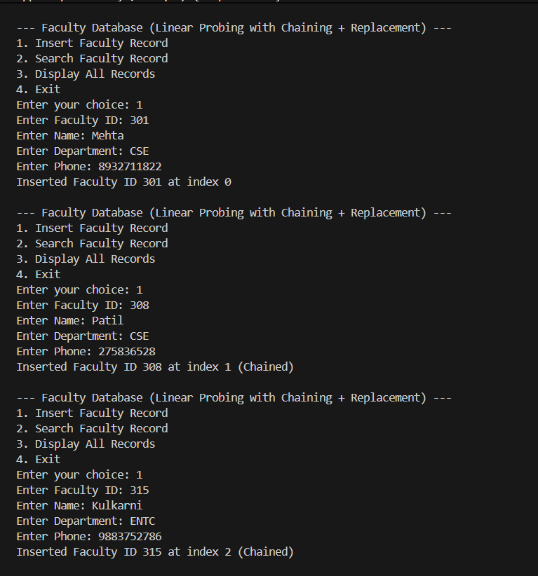
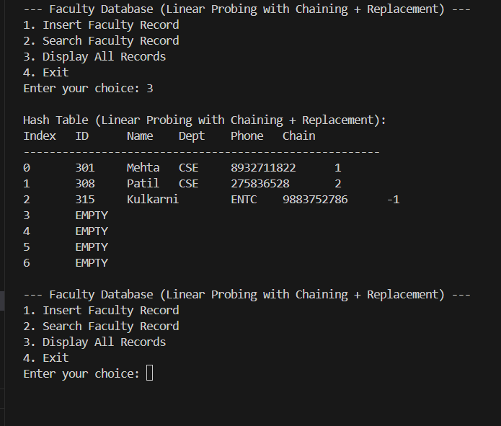

Problem 3 : WAP to simulate employee databases as a hash table. Search a particular faculty by using Mid square method as a hash function for linear probing method of collision handling technique. Assume suitable data for faculty record.

CODE:
#include <iostream>
#include <string>
#include <cmath>
using namespace std;

// Structure for Employee / Faculty record
struct Employee {
int id;
string name;
string dept;
float salary;
};

// Hash Table class
class HashTable {
private:
Employee* table;
bool* occupied;
int size;

// --- Hash function: Mid-Square Method ---
int midSquareHash(int key) {
long long square = (long long)key * key; // Step 1: square the key
string s = to_string(square); // Step 2: convert to string

// Step 3: extract middle digits
int len = s.length();
int mid = len / 2;

string midDigits;
if (len >= 4)
midDigits = s.substr(mid - 2, 3); // take 3 middle digits
else
midDigits = s;

int middleNum = stoi(midDigits);
return middleNum % size; // Step 4: modulo table size
}

public:
// Constructor
HashTable(int s) {
size = s;
table = new Employee[size];
occupied = new bool[size];
for (int i = 0; i < size; i++)
occupied[i] = false;
}

// Insert employee record
void insertRecord(int id, string name, string dept, float salary) {
int index = midSquareHash(id);
int start = index;

// Linear probing
while (occupied[index]) {
index = (index + 1) % size;
if (index == start) {
cout << "Hash Table Full! Cannot insert record for ID " << id << endl;
return;
}
}

table[index].id = id;
table[index].name = name;
table[index].dept = dept;
table[index].salary = salary;
occupied[index] = true;

cout << "Inserted Employee ID " << id << " at index " << index << endl;
}

// Search employee by ID
void searchRecord(int id) {
int index = midSquareHash(id);
int start = index;

while (occupied[index]) {
if (table[index].id == id) {
cout << "\nRecord Found at index " << index << ":\n";
cout << "Employee ID : " << table[index].id << endl;
cout << "Name : " << table[index].name << endl;
cout << "Department : " << table[index].dept << endl;
cout << "Salary : " << table[index].salary << endl;
return;
}
index = (index + 1) % size;
if (index == start) break; // Full loop
}

cout << "\nEmployee with ID " << id << " not found!\n";
}

// Display all records
void displayTable() {
cout << "\nHash Table (Mid-Square Hash + Linear Probing):\n";
for (int i = 0; i < size; i++) {
cout << "Index " << i << ": ";
if (occupied[i]) {
cout << "[ID: " << table[i].id
<< ", Name: " << table[i].name
<< ", Dept: " << table[i].dept
<< ", Salary: " << table[i].salary << "]";
} else {
cout << "EMPTY";
}
cout << endl;
}
}
};

// ---------- main() ----------
int main() {
int size;
cout << "Enter hash table size: ";
cin >> size;

HashTable ht(size);
int choice, id;
string name, dept;
float salary;

do {
cout << "\n--- Employee Database (Mid-Square Hash + Linear Probing) ---";
cout << "\n1. Insert Employee Record";
cout << "\n2. Search Employee Record";
cout << "\n3. Display All Records";
cout << "\n4. Exit";
cout << "\nEnter your choice: ";
cin >> choice;

switch (choice) {
case 1:
cout << "Enter Employee ID: ";
cin >> id;
cout << "Enter Name: ";
cin >> name;
cout << "Enter Department: ";
cin >> dept;
cout << "Enter Salary: ";
cin >> salary;
ht.insertRecord(id, name, dept, salary);
break;

case 2:
cout << "Enter Employee ID to search: ";
cin >> id;
ht.searchRecord(id);
break;

case 3:
ht.displayTable();
break;

case 4:
cout << "Exiting...\n";
break;

default:
cout << "Invalid choice!\n";
}

} while (choice != 4);

return 0;
}

OUTPUT:
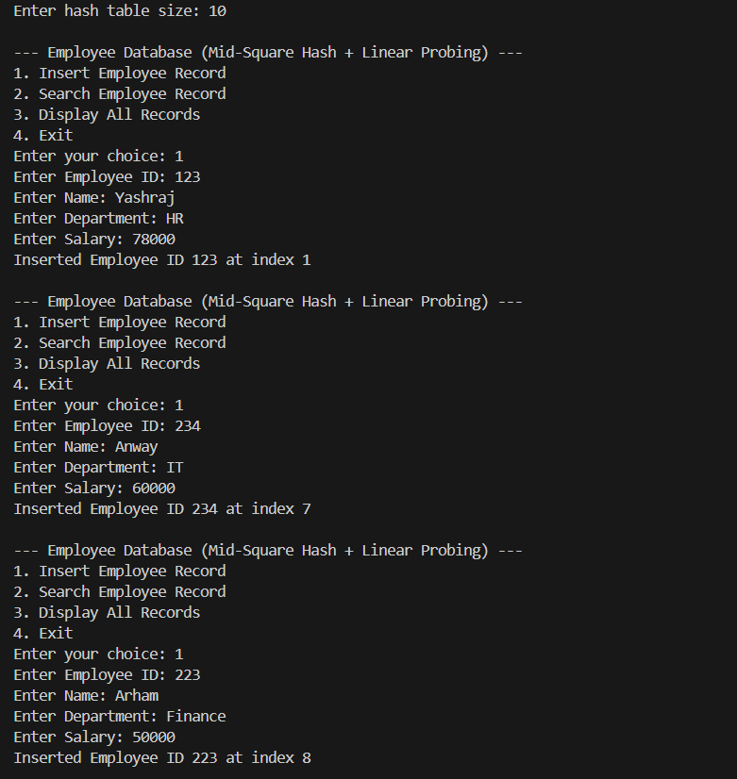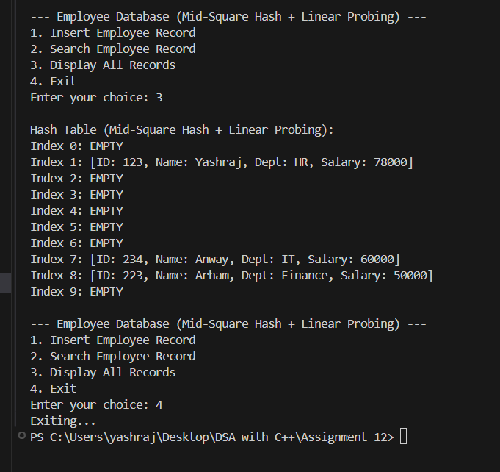

Problem 4 : WAP to simulate student databases as a hash table. a student database management system using hashing
techniques to allow efficient insertion, search, and deletion of student records.

CODE:
#include <iostream>
#include <string>
using namespace std;

// Structure for Student record
struct Student {
int roll;
string name;
string dept;
float marks;
bool isDeleted; // for lazy deletion
};

// Hash Table Class
class HashTable {
private:
Student* table;
bool* occupied;
int size;

// Hash Function (MOD method)
int hashFunction(int key) {
return key % size;
}

public:
// Constructor
HashTable(int s) {
size = s;
table = new Student[size];
occupied = new bool[size];
for (int i = 0; i < size; i++) {
occupied[i] = false;
table[i].isDeleted = false;
}
}

// Insert new record
void insertRecord(int roll, string name, string dept, float marks) {
int index = hashFunction(roll);
int start = index;

while (occupied[index] && !table[index].isDeleted) {
index = (index + 1) % size;
if (index == start) {
cout << "Hash Table Full! Cannot insert record for Roll No: " << roll << endl;
return;
}
}

table[index].roll = roll;
table[index].name = name;
table[index].dept = dept;
table[index].marks = marks;
table[index].isDeleted = false;
occupied[index] = true;

cout << "Record inserted for Roll No: " << roll << " at index " << index << endl;
}

// Search record by Roll Number
void searchRecord(int roll) {
int index = hashFunction(roll);
int start = index;

while (occupied[index]) {
if (!table[index].isDeleted && table[index].roll == roll) {
cout << "\nRecord Found at index " << index << ":\n";
cout << "Roll No: " << table[index].roll << endl;
cout << "Name : " << table[index].name << endl;
cout << "Dept : " << table[index].dept << endl;
cout << "Marks : " << table[index].marks << endl;
return;
}
index = (index + 1) % size;
if (index == start) break;
}

cout << "\nRecord not found for Roll No: " << roll << endl;
}

// Delete record by Roll Number
void deleteRecord(int roll) {
int index = hashFunction(roll);
int start = index;

while (occupied[index]) {
if (!table[index].isDeleted && table[index].roll == roll) {
table[index].isDeleted = true; // lazy delete
cout << "Record deleted for Roll No: " << roll << " at index " << index << endl;
return;
}
index = (index + 1) % size;
if (index == start) break;
}

cout << "Record not found for deletion!\n";
}

// Display all records
void displayTable() {
cout << "\nHash Table (Student Database):\n";
cout << "Index\tRoll\tName\tDept\tMarks\tStatus\n";
cout << "----------------------------------------------\n";
for (int i = 0; i < size; i++) {
cout << i << "\t";
if (occupied[i]) {
if (table[i].isDeleted)
cout << "Deleted\n";
else
cout << table[i].roll << "\t" << table[i].name << "\t"
<< table[i].dept << "\t" << table[i].marks << "\tActive\n";
} else {
cout << "EMPTY\n";
}
}
}
};

// ---------- main() ----------
int main() {
int size;
cout << "Enter hash table size: ";
cin >> size;

HashTable ht(size);
int choice, roll;
string name, dept;
float marks;

do {
cout << "\n--- Student Database Management System (Hash Table) ---";
cout << "\n1. Insert Record";
cout << "\n2. Search Record";
cout << "\n3. Delete Record";
cout << "\n4. Display All Records";
cout << "\n5. Exit";
cout << "\nEnter your choice: ";
cin >> choice;

switch (choice) {
case 1:
cout << "Enter Roll No: ";
cin >> roll;
cout << "Enter Name: ";
cin >> name;
cout << "Enter Department: ";
cin >> dept;
cout << "Enter Marks: ";
cin >> marks;
ht.insertRecord(roll, name, dept, marks);
break;

case 2:
cout << "Enter Roll No to search: ";
cin >> roll;
ht.searchRecord(roll);
break;

case 3:
cout << "Enter Roll No to delete: ";
cin >> roll;
ht.deleteRecord(roll);
break;

case 4:
ht.displayTable();
break;

case 5:
cout << "Exiting...\n";
break;

default:
cout << "Invalid choice!\n";
}
} while (choice != 5);

return 0;
}

OUTPUT:
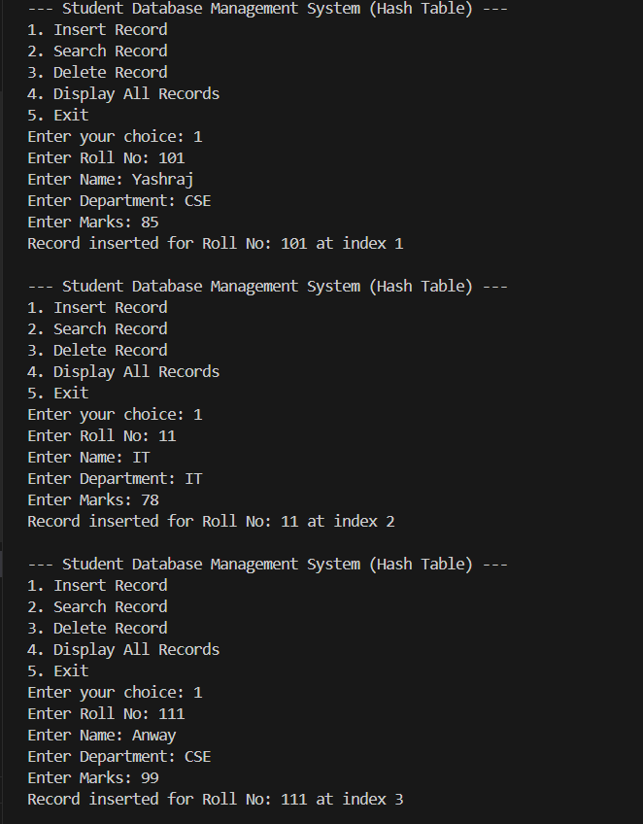
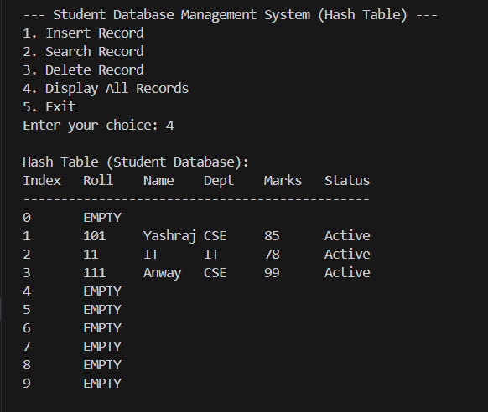

Problem 5 : Design and implement a smart college placement portal that uses advanced hashing techniques to efficiently manage student placement records with high performance and low collision probability, even under dynamic data growth.
CODE:
#include <iostream>
#include <string>
#include <vector>
using namespace std;

struct StudentRecord {
int roll;
string name;
string dept;
float cgpa;
string company;
float salary;
bool isDeleted;

StudentRecord() {
roll = -1;
isDeleted = false;
}
};

class HashTable {
private:
vector<StudentRecord> table;
int size;
int count;
const int PRIME = 7; // used for second hash function

// Primary hash function
int hash1(int key) const {
return key % size;
}

// Secondary hash function for double hashing
int hash2(int key) const {
return PRIME - (key % PRIME);
}

// Load factor calculation
float loadFactor() const {
return (float)count / size;
}

// Rehashing function (doubles table size)
void rehash() {
cout << "\n[Rehashing triggered: Table expanding from " << size << " to " << size * 2 << "]\n";

vector<StudentRecord> oldTable = table;
size = nextPrime(size * 2); // expand to next prime
table.clear();
table.resize(size);
count = 0;

for (auto &rec : oldTable) {
if (rec.roll != -1 && !rec.isDeleted) {
insertRecord(rec.roll, rec.name, rec.dept, rec.cgpa, rec.company, rec.salary);
}
}
}

// Utility to find next prime number
bool isPrime(int n) {
if (n <= 1) return false;
for (int i = 2; i * i <= n; i++)
if (n % i == 0) return false;
return true;
}

int nextPrime(int n) {
while (!isPrime(n)) n++;
return n;
}

public:
// Constructor
HashTable(int s = 11) {
size = s;
table.resize(size);
count = 0;
}

// Insert record using double hashing
void insertRecord(int roll, string name, string dept, float cgpa, string company, float salary) {
if (loadFactor() > 0.7) rehash();

int index = hash1(roll);
int step = hash2(roll);
int start = index;
int i = 0;

while (table[index].roll != -1 && !table[index].isDeleted) {
i++;
index = (start + i * step) % size;
}

table[index].roll = roll;
table[index].name = name;
table[index].dept = dept;
table[index].cgpa = cgpa;
table[index].company = company;
table[index].salary = salary;
table[index].isDeleted = false;
count++;

cout << "Inserted Record for Roll No " << roll << " at index " << index << endl;
}

// Search record by roll number
void searchRecord(int roll) {
int index = hash1(roll);
int step = hash2(roll);
int start = index;
int i = 0;

while (table[index].roll != -1) {
if (!table[index].isDeleted && table[index].roll == roll) {
cout << "\nRecord Found at index " << index << ":\n";
cout << "Roll No : " << table[index].roll << endl;
cout << "Name : " << table[index].name << endl;
cout << "Dept : " << table[index].dept << endl;
cout << "CGPA : " << table[index].cgpa << endl;
cout << "Company : " << table[index].company << endl;
cout << "Salary : " << table[index].salary << endl;
return;
}
i++;
index = (start + i * step) % size;
}

cout << "Record not found for Roll No: " << roll << endl;
}

// Delete record
void deleteRecord(int roll) {
int index = hash1(roll);
int step = hash2(roll);
int start = index;
int i = 0;

while (table[index].roll != -1) {
if (!table[index].isDeleted && table[index].roll == roll) {
table[index].isDeleted = true;
cout << "Record deleted for Roll No: " << roll << endl;
return;
}
i++;
index = (start + i * step) % size;
}
cout << "Record not found for deletion!\n";
}

// Display all records
void displayTable() {
cout << "\n-------------------------------------------------------------\n";
cout << "Index\tRoll\tName\tDept\tCGPA\tCompany\t\tSalary\n";
cout << "-------------------------------------------------------------\n";
for (int i = 0; i < size; i++) {
if (table[i].roll != -1 && !table[i].isDeleted)
cout << i << "\t" << table[i].roll << "\t" << table[i].name << "\t"
<< table[i].dept << "\t" << table[i].cgpa << "\t"
<< table[i].company << "\t" << table[i].salary << endl;
else
cout << i << "\tEMPTY\n";
}
}
};

// ---------- main() ----------
int main() {
HashTable portal;
int choice, roll;
string name, dept, company;
float cgpa, salary;

do {
cout << "\n====== SMART COLLEGE PLACEMENT PORTAL (Advanced Hashing) ======";
cout << "\n1. Insert Student Record";
cout << "\n2. Search Student Record";
cout << "\n3. Delete Student Record";
cout << "\n4. Display All Records";
cout << "\n5. Exit";
cout << "\nEnter your choice: ";
cin >> choice;

switch (choice) {
case 1:
cout << "Enter Roll No: "; cin >> roll;
cout << "Enter Name: "; cin >> name;
cout << "Enter Department: "; cin >> dept;
cout << "Enter CGPA: "; cin >> cgpa;
cout << "Enter Company Placed: "; cin >> company;
cout << "Enter Salary: "; cin >> salary;
portal.insertRecord(roll, name, dept, cgpa, company, salary);
break;

case 2:
cout << "Enter Roll No to search: ";
cin >> roll;
portal.searchRecord(roll);
break;

case 3:
cout << "Enter Roll No to delete: ";
cin >> roll;
portal.deleteRecord(roll);
break;

case 4:
portal.displayTable();
break;

case 5:
cout << "Exiting Smart Portal...\n";
break;

default:
cout << "Invalid choice!\n";
}

} while (choice != 5);

return 0;
}

OUTPUT:
